**Summary of the 2021 Wisconsin Spring Waterfowl Survey**

June 23, 2021

Written and Analyzed by Drew Fowler

Office of Applied Sciences

**Overview:**

The Wisconsin Department of Natural Resources flew the Aerial Spring Breeding Waterfowl Survey in 2021 following a suspension in data collection in 2020 due to the COVID-19 pandemic. This suspension resulted in the first gap of survey data since data collection began in 1973. In this report I summarize results from the 2021 survey including survey counts of priority waterfowl species and total wetlands, which the latter are used as a proxy for habitat availability and conditions. In addition to the summary statistics and graphics that follow in this report, I first offer two notable discussion points: 1) the sensitivity to survey estimates when Visibility Correction Factors (VCF) fluctuate annually and 2) newly incorporated statistically modeled population estimates that buffer observation error in the survey.

*Sensitivity to survey estimates resulting from variability in the VCF*

Estimates for breeding waterfowl species are derived for a given region by multiplying three parameters: 1) The density of birds per square mile, 2) the square area of the region and 3) the VCF. Of the three parameters, two require annual calculation. Briefly, density of a given species is estimated based on the total number of individuals counted along transects, given the square area of the transects. The VCF is calculated for each species as the ratio of individuals counted on ground transects to the number counted on the same transect but by air. By example, if a summary count of individuals for a given species was 115 on ground transects, but 65 on air transects, the VCF would be 1.77. Therefore, if 2.05 individuals / mi2 were counted on air transect across an entire region encompassing 20,000 mi2, then the survey population would be: 2.05 individuals /mi2 (Density) * 20,000 mi2 (Area)* 1.77 (VCF) and would result in 72,570 breeding waterfowl. Therefore, the VCF serves as a direct multiplier to the population estimate calculated using air observations alone. As a result, substantial annual changes in the VCF can have profound effects on the population estimate (Example estimate is 41,000 when VCF = 1 and 82,000 when VCF =2). Deriving a VCF from a group of transects that is representative of the overall survey area is imperative and standard operating procedure accepts VCF with a coefficient of variation (CV) <20%, which is a standardized measure of dispersion. To achieve VCFs with acceptable CV levels, the minimum number of multiple years of survey data are included in the calculation until a CV of less than 20% is realized. Importantly, the number of years required varies annually across and within priority species. In 2021, the VCF for mallards dropped from 1.659 in 2019 to 1.132 in 2021. Though bird density per square mile remained relatively the same in 2021 compared to 2019, the lower VCF for 2021 resulted in a much lower total mallard population estimate. The reason for such a lower VCF in 2021 stems from the near identical count of mallards by ground observers (*n* = 188) as air observers (*n* = 186) in 2021. Historically counts have been much more disparate (see figures 13-17), with ground observers counting more than air observers. Combined with the fact that VCF for mallards generally require only two years of data to meet an acceptable CV < 20% and that the 2019 VCF was based on increased parity in ground and air counts, the 2021 VCF was one of the lowest VCFs for mallards in the last 20 years. Increased parity in air and ground counts could be the result of many speculative factors, but could include: improved detection from air observers because of gained experience, improved detection from air observers because of environmental factors like wetland availability that concentrate birds in detectable landscapes, or decreased detection from ground observers (note: the survey assumes perfect detection from ground observers). Irrespective of the mechanism, understanding the sensitivity of population estimates to changes in VCF is important context when interpreting this year’s mallard population estimate.

*State-space model population estimates*

Because annual spring breeding survey estimates are an unknown integration of both true annual population change and observation error, I elected to model all annual estimates for each priority species using a state-space modeling approach. State-space models are hierarchical models that decompose an observed time series of counts into a process variation (true population size change) and an observation error component (survey count biases). I followed a density-independent approach and details of the modeling process can be found in Kéry and Schaub 2012[1]. State-space models offer at least two important advantages. First, modeled survey estimates smooth out drastic annual changes in raw survey estimates that are biologically unrealistic (i.e. mallard abundance changing from roughly 250K in 1999, to 450K in 2000, and then to 180K in 2001). Secondly, a Bayesian state-space model allows for estimate prediction, even when counts are unavailable. In light of missing data for 2020, modeled estimates are available to fill in the gap. Therefore, in the following summaries of priority breeding waterfowl estimates, I reference abundance and percent changes in light of the *modeled survey estimates* rather than the raw survey estimates, but provide both in the tables and figures for comparison. It is my recommendation that Wildlife Management staff present both the modeled survey estimates along with the raw survey estimates, and not the raw survey estimates by themselves. Accordingly, the annual report should explain what the state-space model does and why it was used.

**Wetlands:**

Total non-linear basins were down 37% from 2019 in the SEC (Table 1) but still 19% above the long-term (47-yr) mean, up 11% from 2019 in the NHI (Table 2) and 25% above the long-term mean, and up <1% from 2019 in the NLO (Table 3) but still 39% above the long-term mean. Non-linear basins were down 50% from 2019 in the SWD (Table 4) and below 4% compared to this region’s long-term (23-yr) mean.

Total linear basins were: up <1% from 2019 in the SEC (Figure 1) and 27% above the long-term mean, up 13% from 2019 in the NHI (Figure 2) and 33% above the long-term mean, and up 22% from 2019 in the NLO (Figure 3) and 48% above the long-term mean. Total linear basins were up 7% from 2019 in the SWD (Figure 4) and 38% above the long-term mean.

**Timing:**

In 2021, the air survey was done in 12 days (April 26th – May 7th). The ground survey was done in 11 days that spanned April 27th – May 7th . The ground counts were all done within 2 days of the air survey (16 transects +1 day and 4 transects +2 days).

**Ducks and Geese:**

Ten flocks of groups over 10 mallards were encountered (One group of 100 and one group of 50). Groups of 5 or more individuals made up 5% of the Wood ducks, 16% of the Canada geese, 25% of the Mallards, 69% of the Blue-winged Teal and 38% of the “other ducks” of the total indicated birds for each species. Flocks of >19 birds are not included in BPOP estimates, as they are considered migrants or non-breeders.

The 2021 population estimate for **all breeding ducks** is **522,546 (95% CI: [385,000; 695,140])**. This estimate is 7% higher compared to the previous year and is 19% above the long-term (47-year mean) (Table 6, Figure 5).

The 2021 population estimate for **Mallards** is **171,345 (95% CI: ± [123,840; 230,392])**. This estimate is 5% lower compared to the previous year and is a 4% decrease from the long-term (47-year mean) (Figure 6).

The 2021 population estimate for **Blue-winged teal** is **65,124 (95% CI: [38,293; 106,146])**. This estimate is 4% higher compared to the previous year but remains 37% below the long-term (47-year mean) (Figure 7).

The 2021 population estimate for **Wood ducks** is **206,343 (95% CI: [116,816; 309,713])**. This estimate is a 31% change compared to the previous year and is 143% above the long-term (47-year mean) (Figure 8).

The 2019 population estimate for **Canada geese** is **181,430 (95% CI: [128,909; 254,459])**. This estimate is a 3% increase compared to the previous year and is 72% above the long-term (47-year mean) (Figure 9).

The 2019 population estimate for **“other ducks”** is **105,042 (95% CI: [49,530;190,878])**. This estimate is a 17% increase compared to the previous year and 68% increase from the long-term (47-year mean) (Figure 10).

**Coots, Cranes, and Swans:**

I conducted summary counts of American coots, Sandhill cranes (Figure 11), as well as Trumpeter swans (Figure 11) for 2021. Prior to 2019, these counts included all birds counted on the air and ground transects. Here, I present only those individuals counted on the air transects to avoid double counting.

Air observers counted a total of 107 coots in 2021. Air observed Sandhill cranes totaled 113 in 2021. Excluding groups greater than 5 (signifying migrant or non-breeding individuals), counts totaled 77 individuals. One pair of Whooping cranes were observed on transect 3 in 2021.

Excluding groups of five or more, the number of Trumpeter Swans counted towards the statewide population estimate was 107 in 2021.

The 2021 population estimate for **Trumpeter swans** is **11,510 (95% CI: [4,958;21,947)** (Table 7; Figure 12).

**Opportunities for future analyses:**

Opportunities exist for further analyses that explore improved ways to handle stochastic variations in annual VCF estimates for each priority species. Comparative analyses that evaluate overall changes on survey abundance estimates with alternative methods to derive VCFs would be useful to inform future directions. Options could include using a fixed VCF across all years, a rolling average VCF, or a VCF using only the current year of survey data. Similar research was recently completed in Michigan and found comparable survey estimates across multiple VCF alternatives (Yost 2020).

Opportunities also exist for improved data visualization and communication of the spring survey data. Technological infrastructure exists to support an online, interactive display of available data and the public report itself. Much more data are available than currently included in the public report and creating an online data dashboard (example here: <https://flexdashboard-pkg.netlify.app/articles/examples.html>) would increase the capacity to house and display survey metrics.

**Table 1** - Numbers of wetlands per square mile observed, 1973-2021, **SEC**

|  |  |  |  |  |  |  |  |  |
| --- | --- | --- | --- | --- | --- | --- | --- | --- |
| **Wetland Type** | **I, II, VI** | **III** | **IV, V** | **VII, VIII** | **Tot. Nonlin.** | **Stream** | **Ditch** | **Tot. Linear** |
| 2011 | 2.6 | 0.7 | 3.8 | 1 | 8.1 | 2 | 2.2 | 4.2 |
| 2012 | 2.1 | 0.6 | 3.1 | 0.7 | 6.4 | 1.6 | 2.6 | 4.1 |
| 2013 | 2.5 | 1.0 | 3.2 | 0.6 | 7.3 | 1.8 | 2.5 | 4.2 |
| 2014 | 3 | 1.0 | 3.1 | 1.2 | 8.3 | 1.7 | 2.8 | 4.5 |
| 2015 | 1.3 | 0.8 | 2.7 | 0.7 | 5.6 | 1.8 | 2.4 | 4.2 |
| 2016 | 2.1 | 0.9 | 3.0 | 1.0 | 6.8 | 1.5 | 2.2 | 3.7 |
| 2017 | 9.2 | 1.1 | 3.6 | 1.9 | 15.8 | 1.9 | 3.2 | 5.1 |
| 2018 | 6.5 | 0.8 | 3.3 | 1.6 | 12.2 | 1.9 | 3.1 | 4.9 |
| 2019 | 7.7 | 2.1 | 4.7 | 2.3 | 16.9 | 1.5 | 3.8 | 5.4 |
| 2020 | NA | NA | NA | NA | NA | NA | NA | NA |
| 2021 | 2.9 | 0.9 | 5.0 | 1.8 | 10.6 | 2.6 | 2.8 | 5.4 |
| % Change from Previous Year | -62.6% | -58.0% | 7.4% | -22.5% | -37.2% | 67.8% | -26.5% | 0.7% |
| Long-term Mean | 3.9 | 0.9 | 3.0 | 1.1 | 8.9 | 1.8 | 2.5 | 4.2 |
| % Change from Long-term Mean | -25.4% | -2.2% | 67.7% | 62.9% | 19.3% | 48.2% | 12.4% | 27.5% |
| 10 Year Mean (2012-2021) | 4.1 | 1.0 | 3.5 | 1.3 | 10.0 | 1.8 | 2.8 | 4.6 |

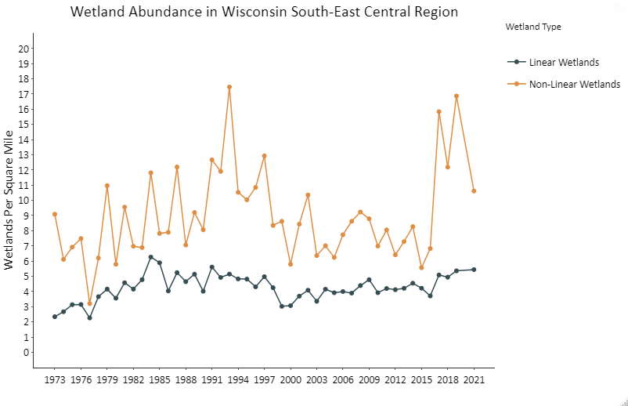

**Figure 1** - Annual variability in total non-linear and liner wetlands surveyed in the South-East Central region during the Wisconsin Spring Duck Survey.

**Table 2** - Numbers of wetlands per square mile observed, 1973-2021, **NHI**

|  |  |  |  |  |  |  |  |  |
| --- | --- | --- | --- | --- | --- | --- | --- | --- |
| **Wetland Type** | **I, II, VI** | **III** | **IV, V** | **VII, VIII** | **Tot. Nonlin.** | **Stream** | **Ditch** | **Tot. Linear** |
| 2011 | 6.2 | 2 | 4.4 | 1.8 | 14.4 | 2.5 | 0.6 | 3.1 |
| 2012 | 3.4 | 1 | 3.8 | 1.0 | 9.3 | 2.3 | 0.3 | 2.6 |
| 2013 | 2.9 | 2.1 | 4 | 0.6 | 9.6 | 2.8 | 0.6 | 3.3 |
| 2014 | 6.4 | 1.8 | 5.7 | 2.4 | 16.3 | 2.9 | 0.6 | 3.5 |
| 2015 | 2.6 | 1.3 | 3.5 | 1.7 | 9.1 | 2.1 | 0.6 | 2.7 |
| 2016 | 2.4 | 1.2 | 3.4 | 1.9 | 8.9 | 1.9 | 0.6 | 2.5 |
| 2017 | 3.5 | 2.0 | 3.6 | 3.4 | 12.5 | 1.8 | 0.9 | 2.7 |
| 2018 | 1.5 | 1.2 | 4.5 | 1.5 | 8.6 | 2.4 | 0.5 | 2.9 |
| 2019 | 2.4 | 2.6 | 5.5 | 1.7 | 12.2 | 2.8 | 0.4 | 3.2 |
| 2020 | NA | NA | NA | NA | NA | NA | NA | NA |
| 2021 | 1.4 | 1.1 | 5.8 | 5.3 | 13.5 | 3.2 | 0.3 | 3.6 |
| % Change from Previous Year | -41.7% | -57.4% | 5.3% | 215.1% | 10.9% | 15.1% | -26.9% | 12.9% |
| Long-term Mean | 3.4 | 1.4 | 4.0 | 2.1 | 10.8 | 2.3 | 0.4 | 2.7 |
| % Change from Long-term Mean | -58.6% | -18.9% | 45.8% | 157.6% | 25.4% | 41.1% | -32.9% | 33.0% |
| 10 Year Mean (2012-2021) | 2.9 | 1.6 | 4.4 | 2.2 | 11.1 | 2.5 | 0.5 | 3.0 |

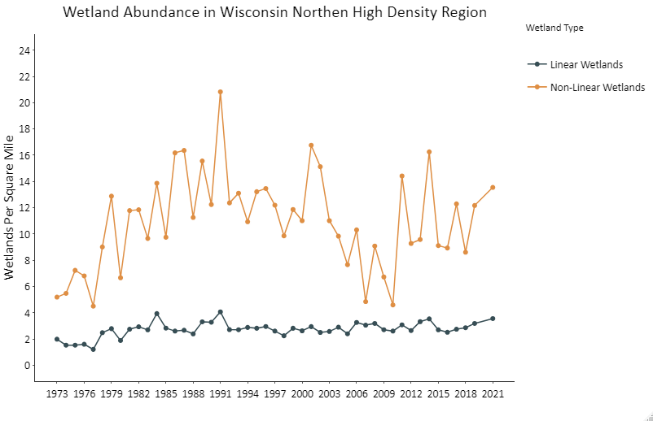

**Figure 2** - Annual variability in total non-linear and liner wetlands surveyed in the Northern High Density region during the Wisconsin Spring Duck Survey.

**Table 3** - Numbers of wetlands per square mile observed, 1973-2021, **NLO**

|  |  |  |  |  |  |  |  |  |
| --- | --- | --- | --- | --- | --- | --- | --- | --- |
| **Wetland Type** | **I, II, VI** | **III** | **IV, V** | **VII, VIII** | **Tot. Nonlin.** | **Stream** | **Ditch** | **Tot. Linear** |
| 2011 | 3.4 | 0.6 | 3.3 | 1.9 | 9.2 | 4.4 | 0.6 | 5 |
| 2012 | 5 | 0.5 | 2.4 | 1.7 | 9.5 | 4.8 | 0.8 | 5.7 |
| 2013 | 3.4 | 1 | 2.5 | 0.7 | 7.6 | 3.8 | 0.8 | 4.6 |
| 2014 | 8.8 | 0.5 | 2.0 | 2.7 | 14.1 | 4.6 | 1.7 | 6.2 |
| 2015 | 1.7 | 0.6 | 1.8 | 1.1 | 5.2 | 3.0 | 0.9 | 3.9 |
| 2016 | 1.8 | 0.8 | 2.1 | 1.2 | 5.9 | 2.8 | 0.8 | 3.6 |
| 2017 | 4.7 | 0.8 | 2.1 | 2.9 | 10.6 | 2.9 | 1.4 | 4.2 |
| 2018 | 2.8 | 0.8 | 2.9 | 2.6 | 9.1 | 5.0 | 1.3 | 6.2 |
| 2019 | 5.6 | 1.7 | 3.5 | 1.9 | 12.6 | 4.0 | 1.2 | 5.2 |
| 2020 | NA | NA | NA | NA | NA | NA | NA | NA |
| 2021 | 3.0 | 1.2 | 3.8 | 4.7 | 12.7 | 4.9 | 1.3 | 6.3 |
| % Change from Previous Year | -46.4% | -28.7% | 9.6% | 150.4% | 0.6% | 23.4% | 8.3% | 21.9% |
| Long-term Mean | 4.0 | 0.8 | 2.2 | 2.0 | 9.1 | 3.5 | 0.8 | 4.3 |
| % Change from Long-term Mean | -25.3% | 50.9% | 70.3% | 131.9% | 39.4% | 40.8% | 61.6% | 47.5% |
| 10 Year Mean (2012-2021) | 4.2 | 0.8 | 2.4 | 1.8 | 9.3 | 3.9 | 1.1 | 4.9 |

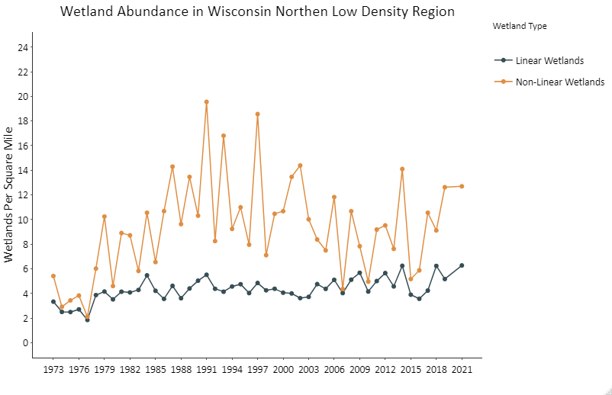

**Figure 3 -** Annual variability in total non-linear and liner wetlands surveyed in the Northern Low Density region during the Wisconsin Spring Duck Survey.

**Table 4** - Numbers of wetlands per square mile observed, 1997-2021, **SWD**

|  |  |  |  |  |  |  |  |  |
| --- | --- | --- | --- | --- | --- | --- | --- | --- |
| **Wetland Type** | **I, II, VI** | **III** | **IV, V** | **VII, VIII** | **Tot. Nonlin.** | **Stream** | **Ditch** | **Tot. Linear** |
| 2011 | 1.1 | 0.2 | 1.8 | 0.6 | 3.7 | 3.1 | 0.5 | 3.6 |
| 2012 | 1 | 0.2 | 1.9 | 0 | 3.1 | 3.6 | 1 | 4.5 |
| 2013 | 1.4 | 0.5 | 1.3 | 0.4 | 3.6 | 3.6 | 0.8 | 4.4 |
| 2014 | 2.3 | 0.6 | 1.7 | 0.5 | 5.1 | 3.4 | 1.3 | 4.7 |
| 2015 | 0.7 | 0.2 | 1.3 | 0.3 | 2.6 | 2.8 | 0.7 | 3.5 |
| 2016 | 0.3 | 0.3 | 1.1 | 0.3 | 2 | 2.5 | 0.8 | 3.3 |
| 2017 | 3.4 | 0.5 | 1.9 | 0.7 | 6.5 | 3.6 | 1.2 | 4.8 |
| 2018 | 1.8 | 0.3 | 1.5 | 0.3 | 3.9 | 3.2 | 0.8 | 4.1 |
| 2019 | 3.2 | 1.0 | 1.8 | 0.7 | 6.7 | 3.6 | 1.4 | 5.0 |
| 2020 | NA | NA | NA | NA | NA | NA | NA | NA |
| 2021 | 0.8 | 0.4 | 1.9 | 0.2 | 3.4 | 4.8 | 0.6 | 5.4 |
| % Change from Previous Year | -75.1% | -61.2% | 8.1% | -73.0% | -49.6% | 33.3% | -57.7% | 7.6% |
| Long-term Mean | 1.5 | 0.3 | 1.6 | 0.3 | 3.5 | 4.6 | 1.1 | 3.9 |
| % Change from Long-term Mean | -48.0% | 22.2% | 20.5% | -23.8% | -4.1% | 4.7% | -46.8% | 38.0% |
| 10 Year Mean (2012-2021) | 1.7 | 0.4 | 1.6 | 0.4 | 4.1 | 3.5 | 1.0 | 4.4 |

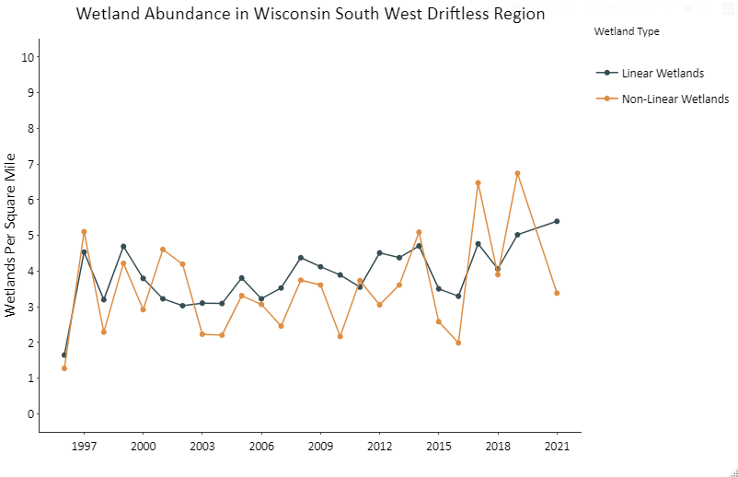

**Figure 4** - Annual variability in total non-linear and liner wetlands surveyed in the South West Driftless region during the Wisconsin Spring Duck Survey

**Table 5** - 2021 Wisconsin Spring Duck Survey waterfowl breeding population estimates.

|  |  |  |  |  |  |
| --- | --- | --- | --- | --- | --- |
| **Species** | **Area of stratum (mi2)** | **Bird density seen form the air (birds/mi2)** | **Aerial visibility correction factor[2]** | **Survey Estimate** | **Standard Error** |
|  |
| **Mallard** |  |  |  |  |  |  |
| Stratum[3] |  |  |  |  |  |  |
| SEC | 17,949 | 3.490 | 1.132 | 70,902 | 2,750 |  |
| NHI | 9,431 | 2.092 | 1.132 | 22,336 | 1,561 |  |
| NLO | 15,979 | 1.928 | 1.132 | 34,877 | 2,624 |  |
| SWD | 12,311 | 1.382 | 1.132 | 19,256 | 1,912 |  |
| Subtotal |  |  |  | **147,371** | **2,402** |  |
|  |  |  |  |  |  |  |
| **Blue-winged teal** |  |  |  |  |  |  |
| Stratum |  |  |  |  |  |  |
| SEC | 17,949 | 0.354 | 5.754 | 36,563 | 2,180 |  |
| NHI | 9,431 | 0.185 | 5.754 | 10,018 | 2,779 |  |
| NLO | 15,979 | 0.041 | 5.754 | 3,772 | 725 |  |
| SWD | 12,311 | 0.352 | 5.754 | 24,900 | 4,515 |  |
| Subtotal |  |  |  | **75,253** | **2,667** |  |
|  |  |  |  |  |  |  |
| **Wood duck** |  |  |  |  |  |  |
| Stratum |  |  |  |  |  |  |
| SEC | 17,949 | 0.975 | 6.614 | 115,713 | 4,969 |  |
| NHI | 9,431 | 0.492 | 6.614 | 30,708 | 2,341 |  |
| NLO | 15,979 | 0.533 | 6.614 | 56,365 | 4,406 |  |
| SWD | 12,311 | 0.461 | 6.614 | 37,505 | 4,998 |  |
| Subtotal |  |  |  | **240,291** | **4,463** |  |
|  |  |  |  |  |  |  |
| **Other duck species[4]** |  |  |  |  |  |  |
| Stratum |  |  |  |  |  |  |
| SEC | 17,949 | 0.216 | 5.323 | 20,644 | 1,912 |  |
| NHI | 9,431 | 1.221 | 5.323 | 61,266 | 6,266 |  |
| NLO | 15,979 | 0.472 | 5.323 | 40,125 | 5,807 |  |
| SWD | 12,311 | 0.000 | 5.323 | 0 | 0 |  |
| Subtotal |  |  |  | **122,035** | **3,998** |  |
|  |  |  |  |  |  |  |
| **Canada Geese** |  |  |  |  |  |  |
| Stratum |  |  |  |  |  |  |
| SEC | 17,949 | 2.906 | 1.817 | 94,790 | 3,110 |  |
| NHI | 9,431 | 1.456 | 1.817 | 24,963 | 2,282 |  |
| NLO | 15,979 | 1.015 | 1.817 | 29,487 | 2,816 |  |
| SWD | 12,311 | 0.933 | 1.817 | 20,883 | 1,972 |  |
| Subtotal |  |  |  | **170,123** | **2,736** |  |

**Table 6** – Statewide breeding waterfowl population survey estimates and Bayesian state-space modeled estimates in Wisconsin, 1973-2021.

|  |  |  |  |  |  |  |  |  |  |  |  |  |
| --- | --- | --- | --- | --- | --- | --- | --- | --- | --- | --- | --- | --- |
| **Year** | **Mallards** | | **Blue-Winged Teal** | | **Wood Ducks** | | **Other Ducks** | | **Total Ducks** | | **Canada Geese** | |
|  | **Survey Estimate** | **Modeled Estimate** | **Survey Estimate** | **Modeled Estimate** | **Survey Estimate** | **Modeled Estimate** | **Survey Estimate** | **Modeled Estimate** | **Survey Estimate** | **Modeled Estimate** | **Survey Estimate** | **Modeled Estimate** |
| 1973 | *106,956* | **102,920** | *185,361* | **210,749** | *6,636* | **9,485** | *113,753* | **86,594** | *412,706* | **407,707** | *NA* | **NA** |
| 1974 | *94,322* | **101,617** | *254,440* | **214,109** | *15,442* | **14,993** | *70,978* | **66,344** | *435,182* | **407,155** | *NA* | **NA** |
| 1975 | *120,460* | **105,302** | *237,426* | **205,968** | *26,520* | **21,889** | *42,472* | **49,100** | *426,878* | **392,143** | *NA* | **NA** |
| 1976 | *109,862* | **101,463** | *200,649* | **188,930** | *26,164* | **23,470** | *42,851* | **41,090** | *379,526* | **363,511** | *NA* | **NA** |
| 1977 | *91,657* | **93,302** | *195,737* | **170,791** | *21,475* | **22,029** | *14,411* | **29,977** | *323,280* | **330,469** | *NA* | **NA** |
| 1978 | *61,646* | **85,611** | *134,205* | **147,303** | *17,811* | **21,326** | *57,686* | **40,568** | *271,348* | **300,638** | *NA* | **NA** |
| 1979 | *78,600* | **91,605** | *120,892* | **130,629** | *31,697* | **27,804** | *34,541* | **36,720** | *265,730* | **290,058** | *NA* | **NA** |
| 1980 | *116,488* | **104,489** | *69,404* | **117,127** | *29,261* | **27,976** | *32,920* | **35,496** | *248,073* | **288,822** | *NA* | **NA** |
| 1981 | *142,831* | **112,388** | *258,054* | **127,035** | *40,817* | **29,084** | *63,336* | **38,311** | *505,038* | **318,321** | *NA* | **NA** |
| 1982 | *89,472* | **105,857** | *98,641* | **105,046** | *9,524* | **15,572** | *21,081* | **24,222** | *218,718* | **261,064** | *NA* | **NA** |
| 1983 | *119,462* | **109,208** | *60,465* | **88,546** | *10,642* | **16,202** | *11,727* | **17,188** | *202,296* | **238,877** | *NA* | **NA** |
| 1984 | *104,759* | **106,086** | *64,951* | **83,022** | *28,294* | **26,178** | *11,991* | **15,524** | *209,995* | **236,120** | *NA* | **NA** |
| 1985 | *73,909* | **102,702** | *84,199* | **83,500** | *25,757* | **32,466** | *8,929* | **14,947** | *192,794* | **241,436** | *NA* | **NA** |
| 1986 | *110,763* | **116,094** | *51,266* | **81,108** | *82,747* | **62,442** | *17,237* | **19,560** | *262,013* | **276,583** | *11,129* | **12,733** |
| 1987 | *136,947* | **132,142** | *124,021* | **90,855** | *98,349* | **75,395** | *30,518* | **26,653** | *389,835* | **323,652** | *14,519* | **15,359** |
| 1988 | *148,901* | **146,310** | *67,580* | **88,732** | *54,260* | **61,228** | *16,333* | **28,980** | *287,074* | **336,255** | *15,339* | **18,915** |
| 1989 | *180,676* | **161,527** | *125,062* | **94,819** | *59,676* | **63,634** | *97,099* | **54,679** | *462,513* | **384,443** | *53,040* | **32,242** |
| 1990 | *151,356* | **167,139** | *70,169* | **90,849** | *67,065* | **69,536** | *40,040* | **54,902** | *328,630* | **391,309** | *22,840* | **26,461** |
| 1991 | *172,423* | **182,300** | *67,023* | **94,370** | *69,349* | **77,319** | *126,986* | **82,063** | *435,781* | **439,352** | *23,931* | **27,515** |
| 1992 | *249,727* | **206,027** | *179,125* | **110,335** | *145,118* | **106,151** | *109,834* | **78,754** | *683,804* | **500,819** | *34,668* | **33,051** |
| 1993 | *174,531* | **208,618** | *98,859* | **107,409** | *73,866* | **83,888** | *32,115* | **56,026** | *379,371* | **472,745** | *34,386* | **36,027** |
| 1994 | *283,400* | **235,351** | *144,041* | **109,938** | *63,078* | **80,883** | *80,710* | **68,369** | *571,229* | **516,246** | *36,125* | **40,841** |
| 1995 | *242,166* | **240,615** | *117,945* | **102,633** | *153,658* | **115,684** | *78,650* | **68,285** | *592,419* | **529,701** | *59,240* | **53,521** |
| 1996 | *314,413* | **248,644** | *69,960* | **90,541** | *76,475* | **94,441** | *75,457* | **61,949** | *536,305* | **510,754** | *55,888* | **59,731** |
| 1997 | *180,968* | **226,190** | *70,795* | **86,681** | *119,410* | **113,281** | *38,140* | **45,654** | *409,313* | **474,932** | *78,566* | **73,318** |
| 1998 | *186,891* | **228,881** | *75,975* | **86,914** | *121,713* | **119,599** | *28,219* | **38,004** | *412,798* | **477,697** | *74,712* | **80,376** |
| 1999 | *248,446* | **255,175** | *84,418* | **90,711** | *113,898* | **120,060** | *29,869* | **38,076** | *476,631* | **513,227** | *101,183* | **97,511** |
| 2000 | *453,979* | **292,589** | *117,338* | **95,183** | *141,882* | **133,390** | *31,191* | **42,374** | *744,390* | **577,674** | *129,508* | **113,719** |
| 2001 | *183,453* | **259,586** | *77,310* | **92,682** | *131,051* | **130,816** | *48,312* | **57,525** | *440,126* | **549,383** | *94,066* | **109,369** |
| 2002 | *378,542* | **284,894** | *66,033* | **94,468** | *135,129* | **129,976** | *161,087* | **91,700** | *740,791* | **609,455** | *118,476* | **129,052** |
| 2003 | *261,332* | **267,087** | *90,136* | **107,053** | *110,109* | **119,100** | *71,888* | **80,291** | *533,465* | **590,014** | *241,930* | **174,369** |
| 2004 | *229,175* | **254,175** | *213,755* | **131,007** | *114,550* | **119,845** | *94,014* | **83,570** | *651,494* | **612,644** | *149,003* | **150,155** |
| 2005 | *317,224* | **257,999** | *195,239* | **134,893** | *141,152* | **129,957** | *70,655* | **76,669** | *724,270* | **614,821** | *123,836* | **134,617** |
| 2006 | *219,494* | **233,271** | *108,701* | **123,614** | *121,650* | **119,393** | *72,726* | **74,454** | *522,571* | **558,868** | *134,683* | **133,985** |
| 2007 | *210,219* | **218,357** | *124,093* | **120,798** | *87,875* | **104,596** | *48,427* | **69,902** | *470,614* | **532,513** | *125,195* | **129,790** |
| 2008 | *188,429* | **206,282** | *179,549* | **119,631** | *126,440* | **119,047** | *132,506* | **90,017** | *626,924* | **545,429** | *116,715* | **129,476** |
| 2009 | *200,497* | **202,508** | *112,793* | **102,137** | *113,523* | **115,278** | *75,602* | **75,287** | *502,416* | **506,587** | *148,293* | **145,002** |
| 2010 | *199,107* | **198,273** | *50,188* | **84,826** | *103,769* | **112,745** | *32,757* | **62,327** | *385,821* | **470,719** | *157,622* | **154,209** |
| 2011 | *187,862* | **192,828** | *90,803* | **83,807** | *146,471* | **126,801** | *88,610* | **84,643** | *513,746* | **490,805** | *176,095* | **160,397** |
| 2012 | *196,950* | **190,140** | *105,791* | **80,608** | *106,626* | **109,650** | *111,712* | **104,895** | *521,079* | **492,833** | *145,386* | **148,089** |
| 2013 | *181,200* | **182,858** | *73,483* | **69,752** | *91,516* | **98,868** | *181,141* | **124,654** | *527,340* | **479,719** | *138,925* | **140,725** |
| 2014 | *158,747* | **175,601** | *34,337* | **58,651** | *104,140* | **98,561** | *97,875* | **102,659** | *395,099* | **437,404** | *126,299* | **132,792** |
| 2015 | *176,200* | **177,076** | *59,083* | **58,011** | *68,142* | **83,337** | *69,415* | **89,422** | *372,840* | **419,063** | *119,212* | **129,764** |
| 2016 | *164,147* | **177,480** | *37,936* | **55,993** | *89,775* | **92,845** | *98,640* | **95,443** | *390,498* | **424,933** | *129,562* | **137,053** |
| 2017 | *180,930* | **184,112** | *85,526* | **60,615** | *102,397* | **102,360** | *110,246* | **96,010** | *479,099* | **449,173** | *158,023* | **152,487** |
| 2018 | *216,652* | **193,325** | *45,130* | **58,291** | *100,055* | **106,508** | *77,560* | **83,179** | *439,397* | **449,531** | *157,950* | **159,429** |
| 2019 | *204,296* | **190,335** | *61,946* | **60,927** | *100,027* | **115,481** | *47,392* | **73,330** | *413,661* | **455,343** | *171,407* | **169,337** |
| 2020 | *NA* | **181,006** | *NA* | **62,807** | *NA* | **157,236** | *NA* | **89,501** | *NA* | **488,976** | *NA* | **176,522** |
| 2021 | *147,371* | **171,345** | *75,253* | **65,124** | *240,291* | **206,343** | *122,035* | **105,042** | *584,950* | **522,546** | *170,123* | **181,430** |
| Mean (73-21) | 182,247 | **178,953** | 110,731 | 104,480 | 84,693 | **84,983** | 66,077 | **62,672** | 443,747 | **438,826** | 104,225 | **105,538** |
| Mean (12-21) | 180,721 | **182,328** | 64,276 | 63,078 | 111,441 | **117,119** | 101,780 | **96,414** | 458,218 | **461,952** | 146,321 | **152,763** |
| % Change from Previous Year |  | -5.3% |  | 3.7% |  | 31.2% |  | 17.4% |  | 6.9% |  | 2.8% |
| % Change from 1973-2020 Mean |  | -4.3% |  | -37.7% |  | 142.8% |  | 67.6% |  | 19.1% |  | 71.9% |

**Table 7** – Annual statewide estimates of breeding Trumpeter swan abundance in Wisconsin, 2005-2021. Data include abundance estimates from the Aerial Spring Breeding Duck Survey as well model predicated abundance estimates from a Bayesian state-space model.

|  |  |  |
| --- | --- | --- |
| **Trumpeter Swan Statewide Annual Trends** | | |
| **Year** | **Survey Abundance Estimate** | **Modeled Abundance Estimate** |
| 2005 | *1,387* | **673** |
| 2006 | *193* | **423** |
| 2007 | *455* | **517** |
| 2008 | *248* | **562** |
| 2009 | *1,340* | **979** |
| 2010 | *1,237* | **1,210** |
| 2011 | *1,408* | **1,476** |
| 2012 | *1,999* | **1,906** |
| 2013 | *2,292* | **2,341** |
| 2014 | *2,979* | **2,917** |
| 2015 | *3,679* | **3,600** |
| 2016 | *5,029* | **4,517** |
| 2017 | *4,833* | **5,133** |
| 2018 | *5,677* | **6,128** |
| 2019 | *6,106* | **7,192** |
| 2020 | *NA* | **9,366** |
| 2021 | *11,196* | **11,510** |

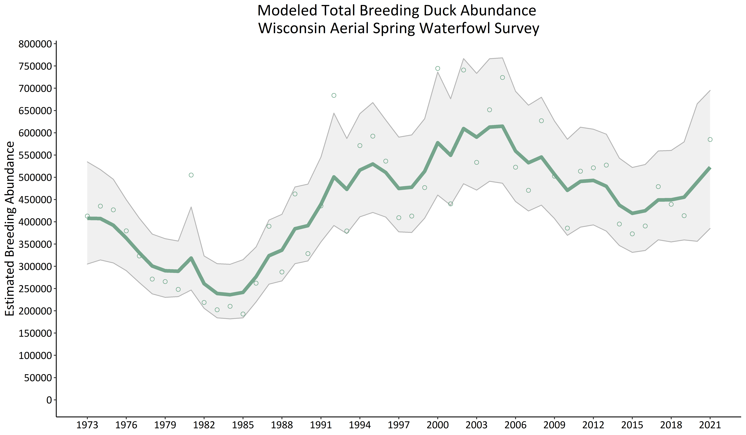

**Figure 5 -** Annual statewide estimates of total breeding duck abundance in Wisconsin, 1973-2021. Depicts abundance estimates from the Aerial Spring Waterfowl Survey (open circles), model predicted abundance estimates (solid line), and 95% credible intervals.

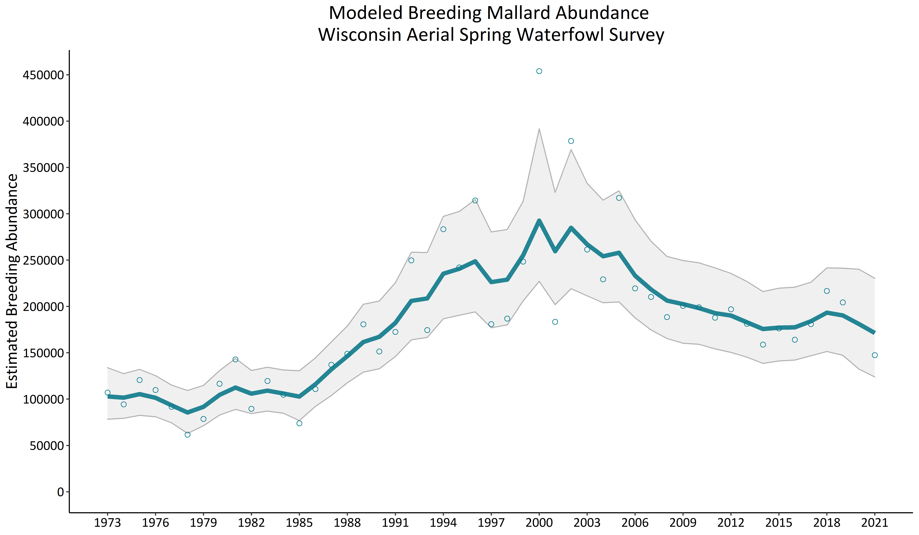

**Figure 6** - Annual statewide estimates of breeding mallard abundance in Wisconsin, 1973-2021. Depicts abundance estimates from the Aerial Spring Waterfowl Survey (open circles), model predicted abundance estimates (solid line), and 95% credible intervals.

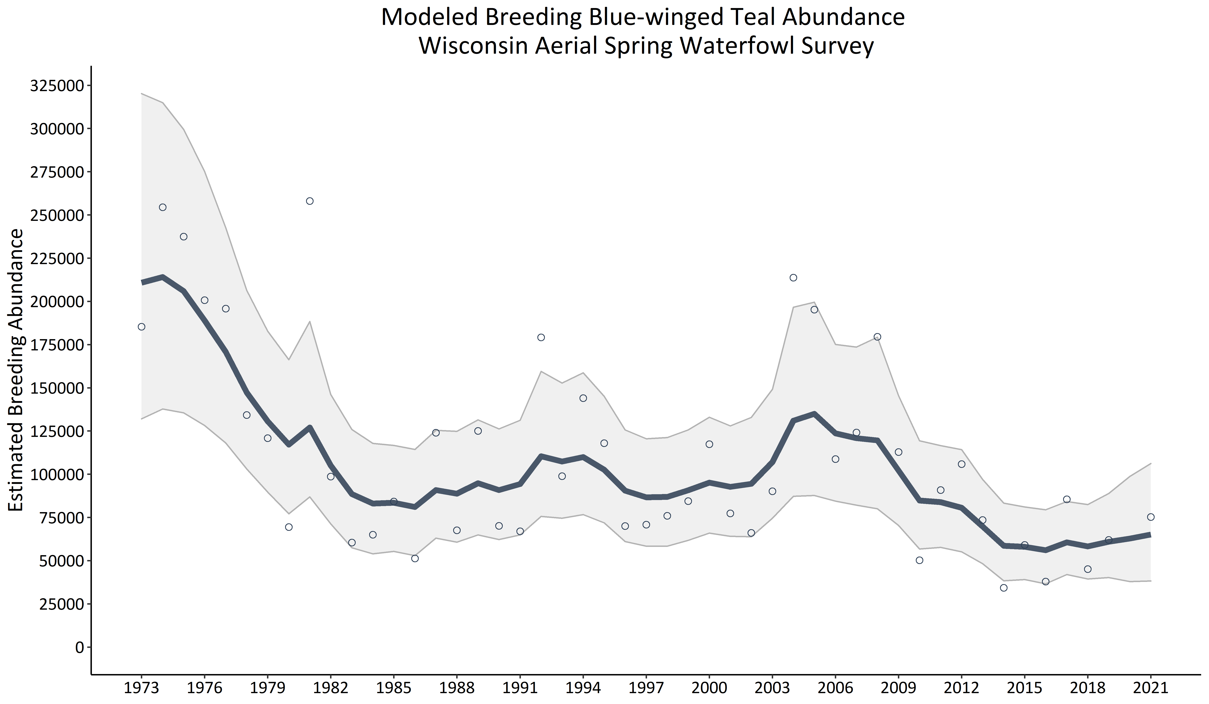

**Figure 7 -** Annual statewide estimates of breeding blue-winged teal abundance in Wisconsin, 1973-2021. Depicts abundance estimates from the Aerial Spring Waterfowl Survey (open circles), model predicted abundance estimates (solid line), and 95% credible intervals.

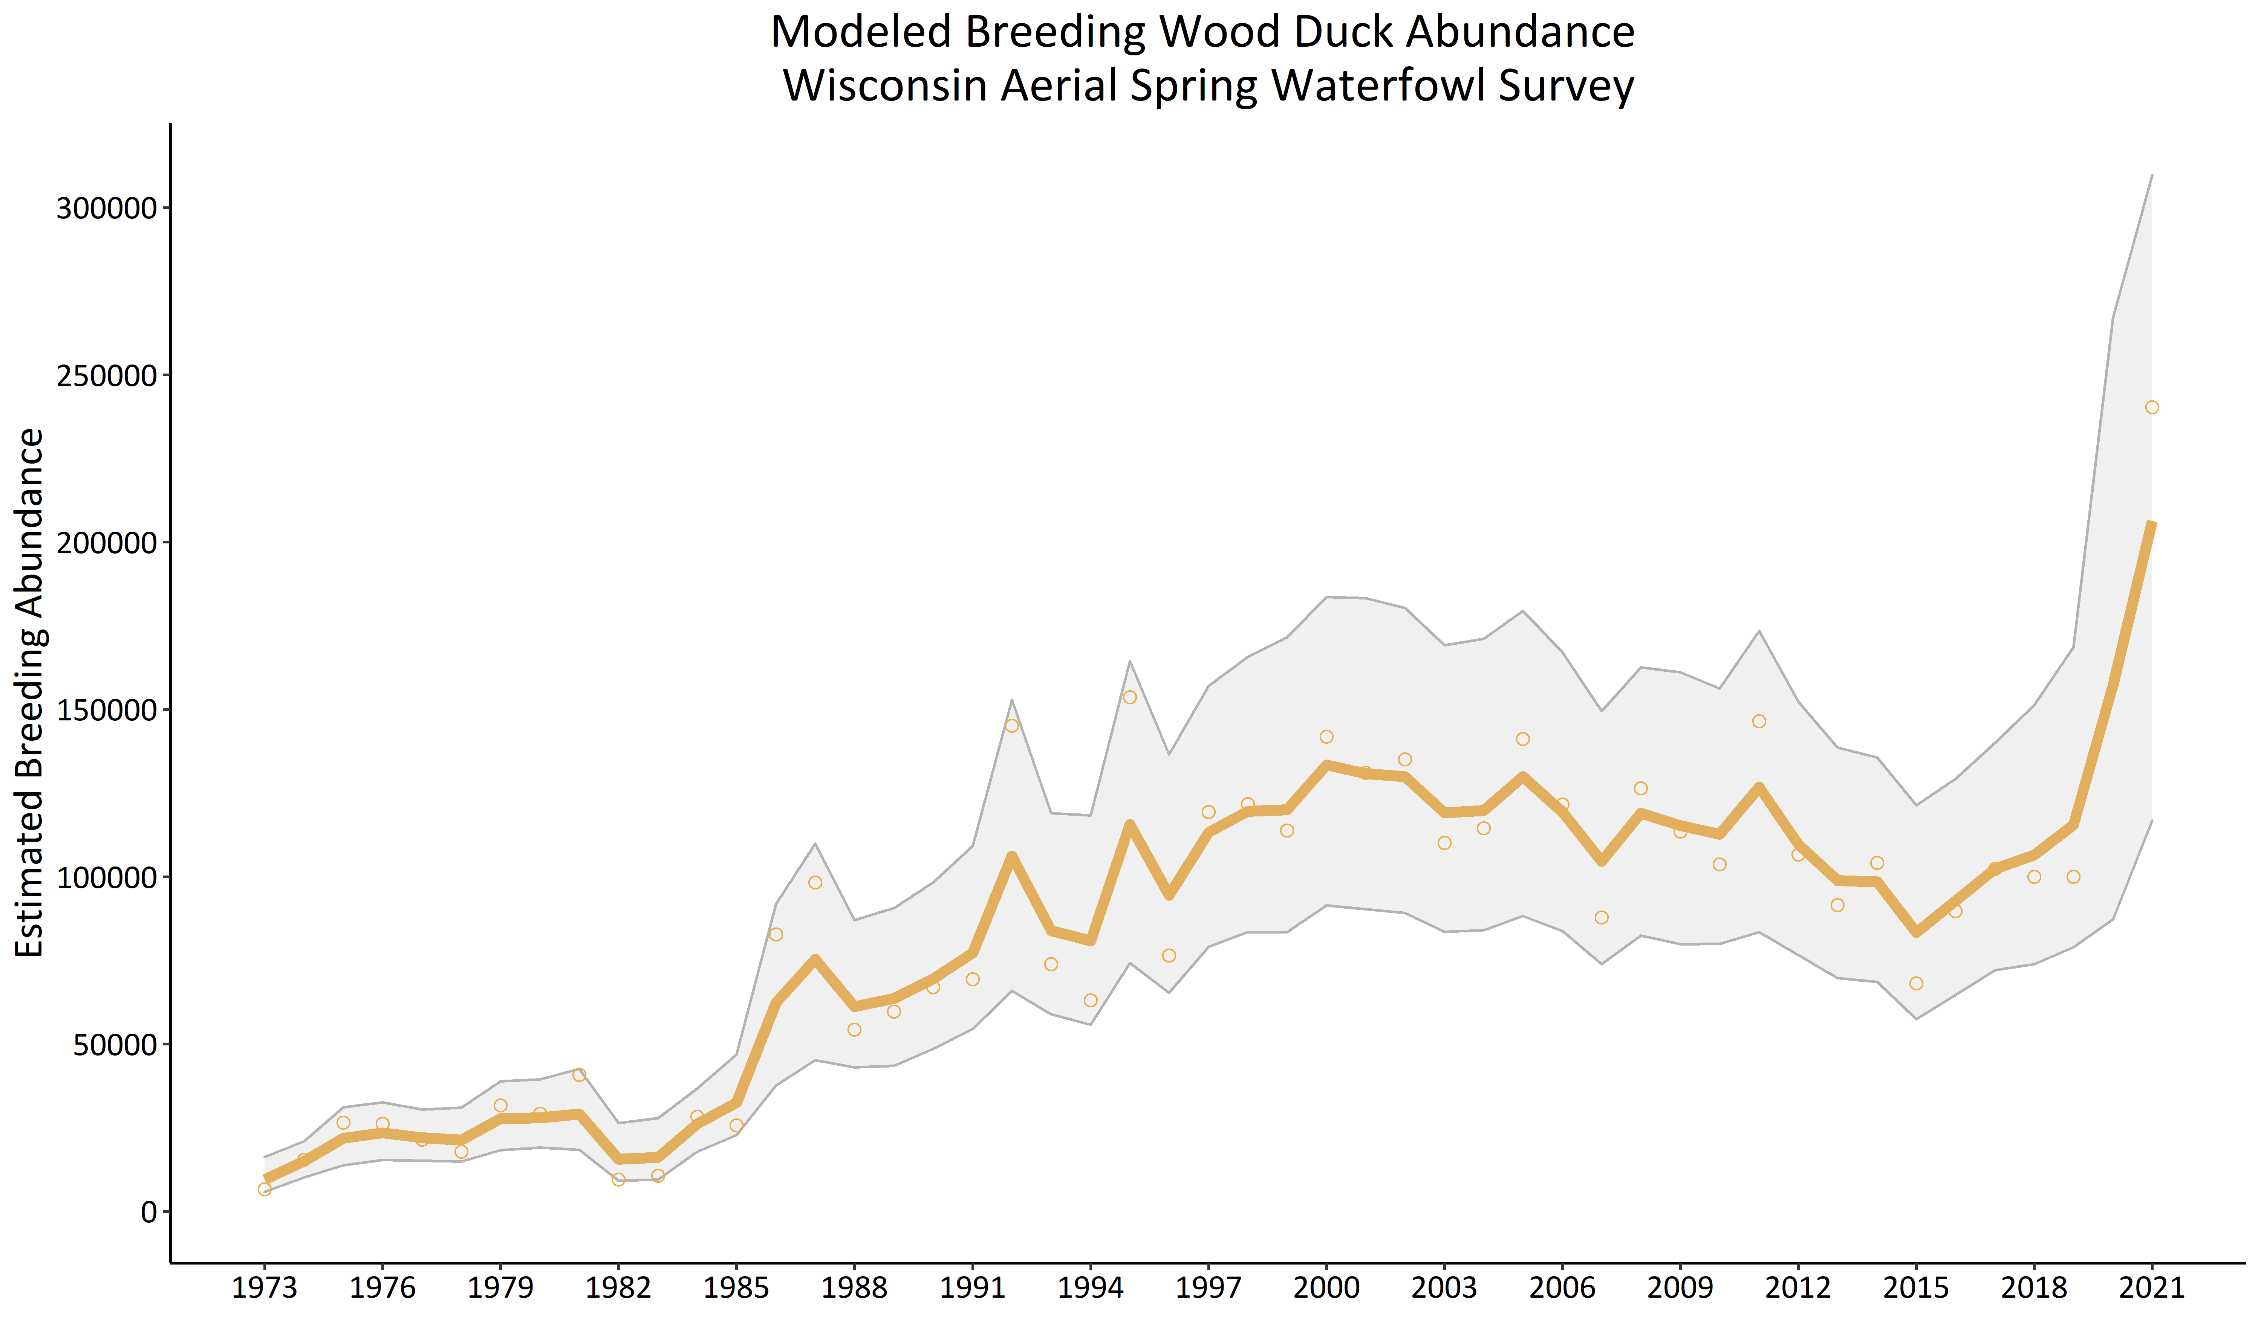

**Figure 8**- Annual statewide estimates of breeding wood duck abundance in Wisconsin, 1973-2021. Depicts abundance estimates from the Aerial Spring Waterfowl Survey (open circles), model predicted abundance estimates (solid line), and 95% credible intervals.

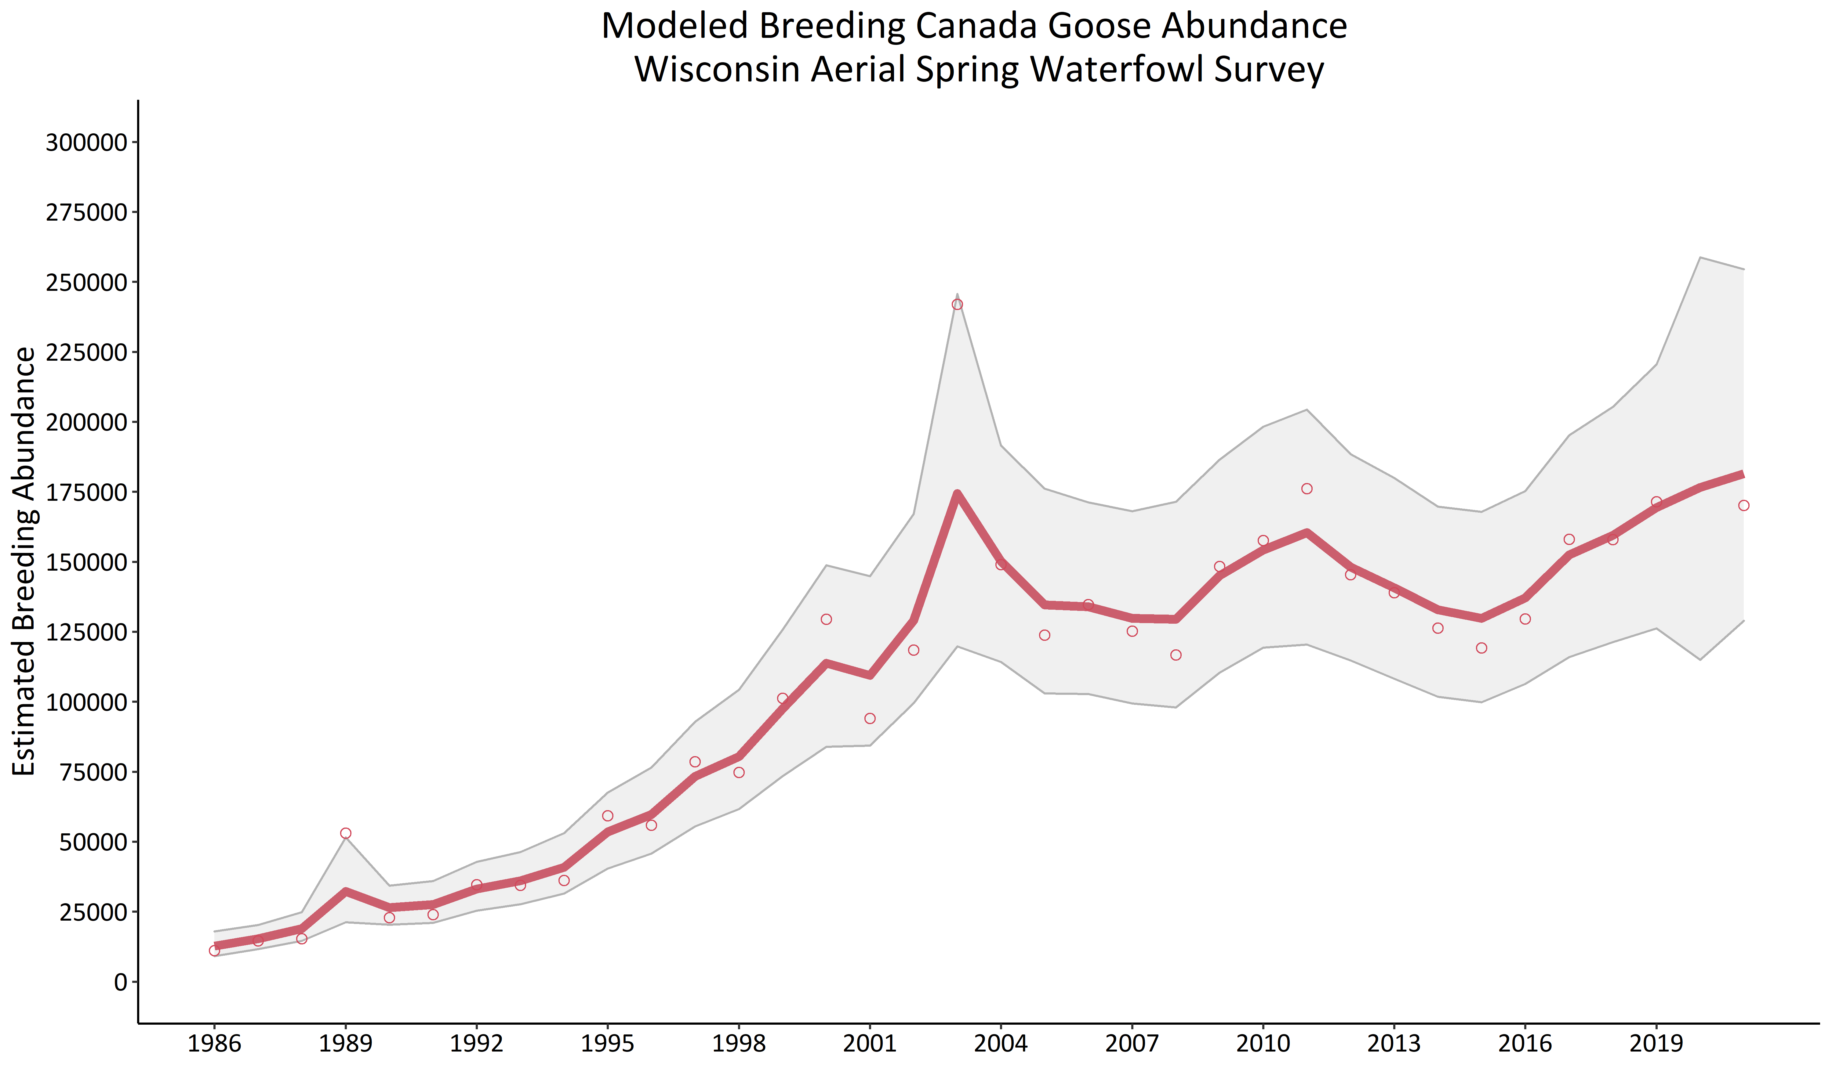

**Figure 9 -** Annual statewide estimates of breeding Canada goose abundance in Wisconsin, 1973-2021. Depicts abundance estimates from the Aerial Spring Waterfowl Survey (open circles), model predicted abundance estimates (solid line), and 95% credible intervals.

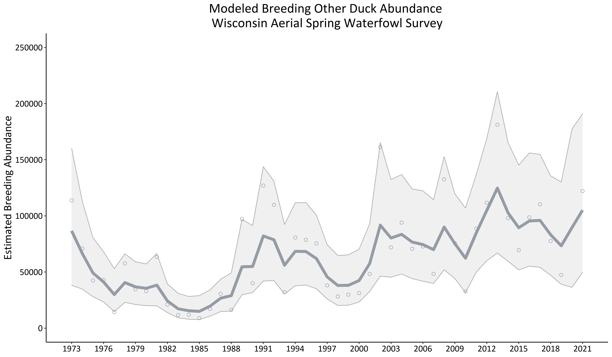

**Figure 10** - Annual statewide estimates of breeding “other duck” abundance in Wisconsin, 1973-2021. Depicts abundance estimates from the Aerial Spring Waterfowl Survey (open circles), model predicted abundance estimates (solid line), and 95% credible intervals.

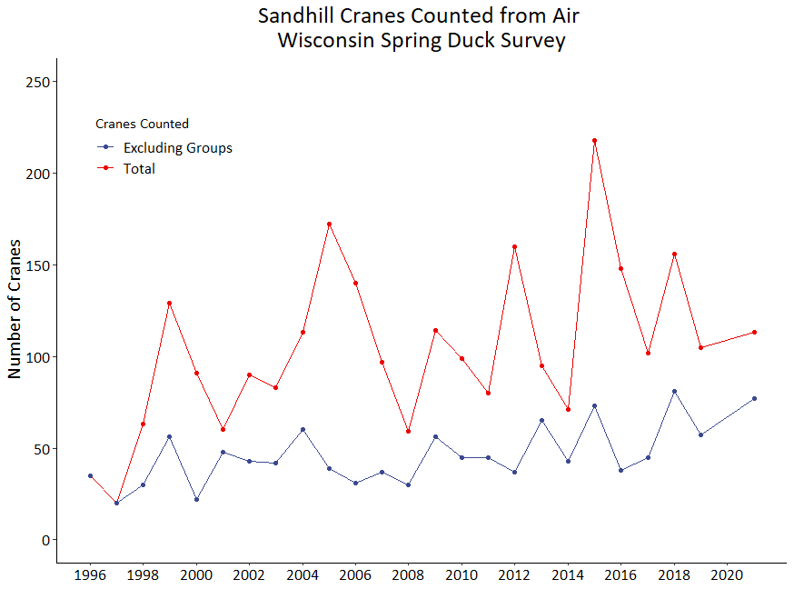

**Figure 11 -** Annual counts of sandhill cranes observed from the air during the Wisconsin Aerial Spring Waterfowl Survey, 1973-2021.

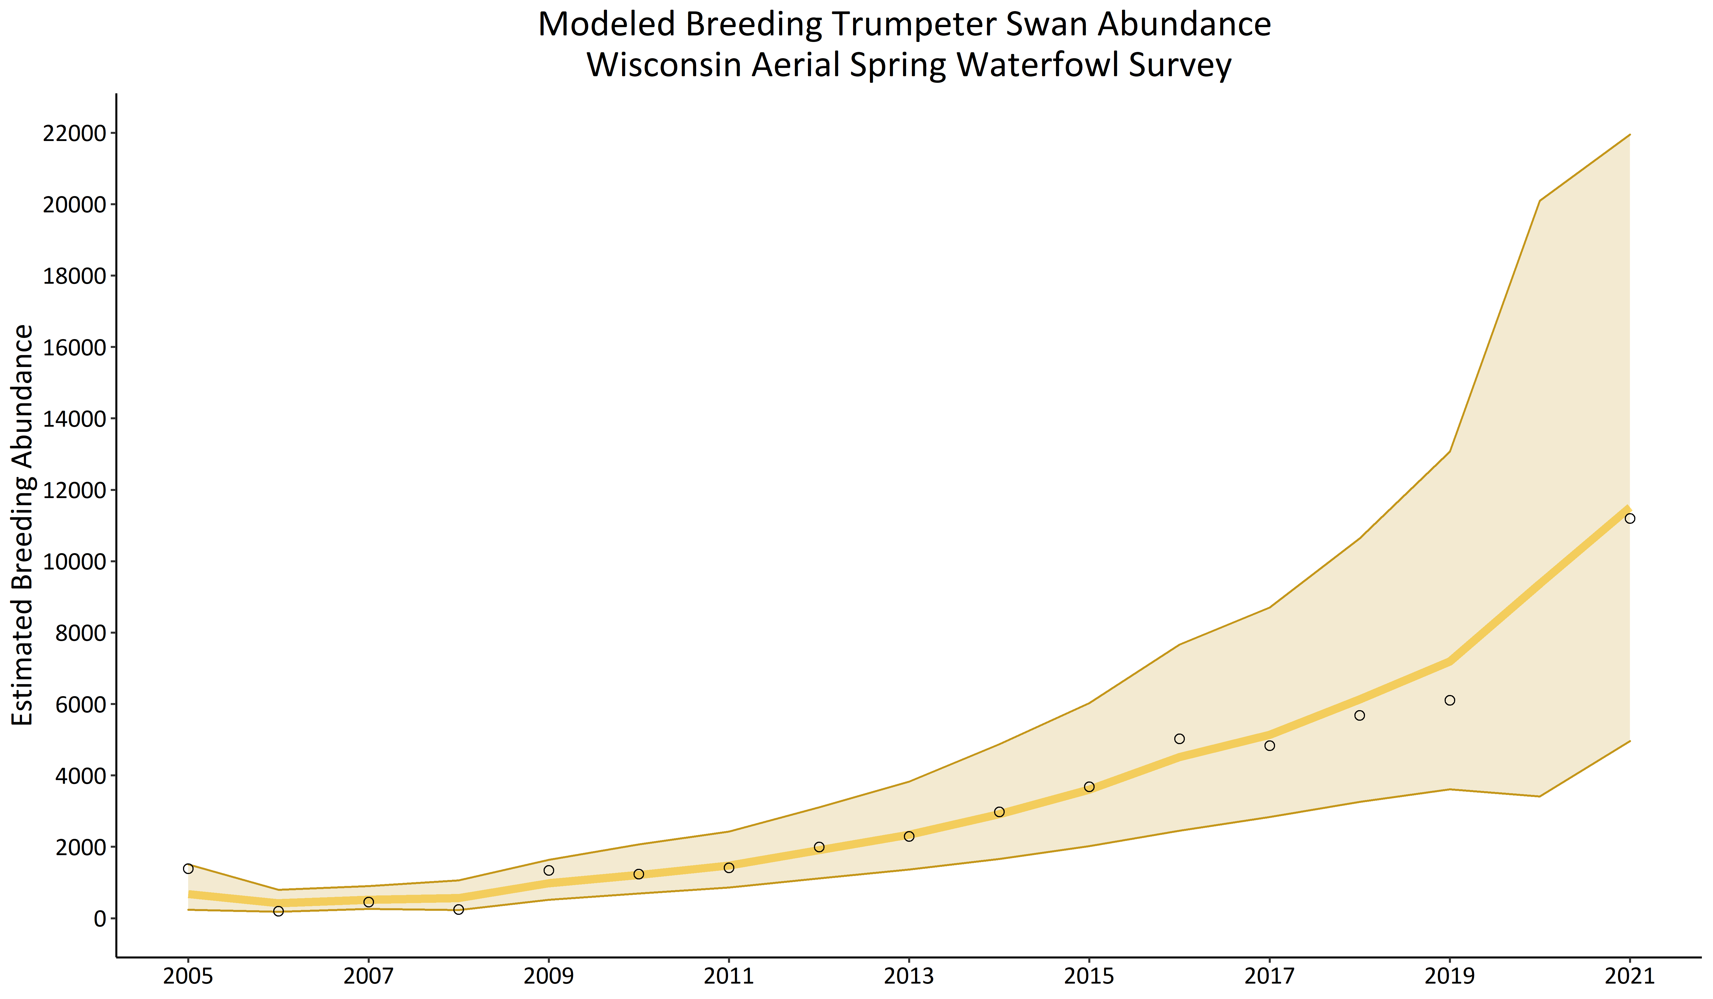

**Figure 12 -** Annual statewide estimates of breeding Trumpeter swan abundance in Wisconsin, 2005-2021. Depicts abundance estimates from the Aerial Spring Waterfowl Survey (open circles), model predicted abundance estimates (solid line), and 95% credible intervals.

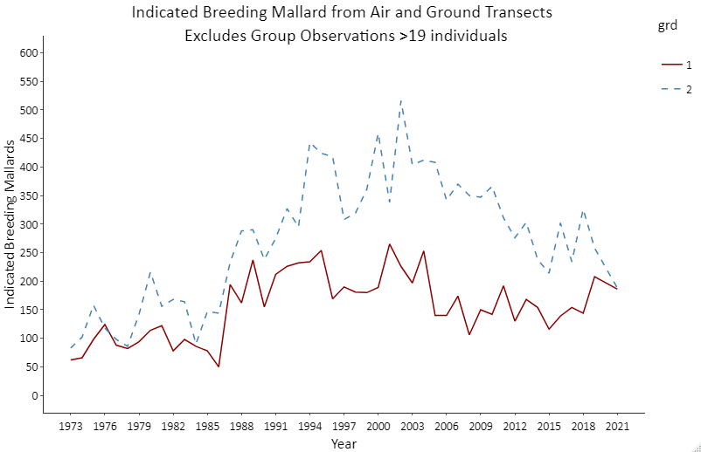

**Figure 13** – Annual relationship between mallard counts by air observers (red line) and ground observers (blue line) during the Wisconsin Aerial Spring Waterfowl Survey, 1973-2021.

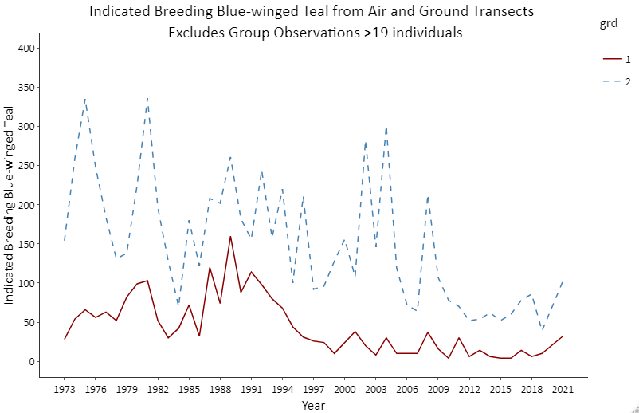

**Figure 14** - Annual relationship between blue-winged teal counts by air observers (red line) and ground observers (blue line) during the Wisconsin Aerial Spring Waterfowl Survey, 1973-2021.

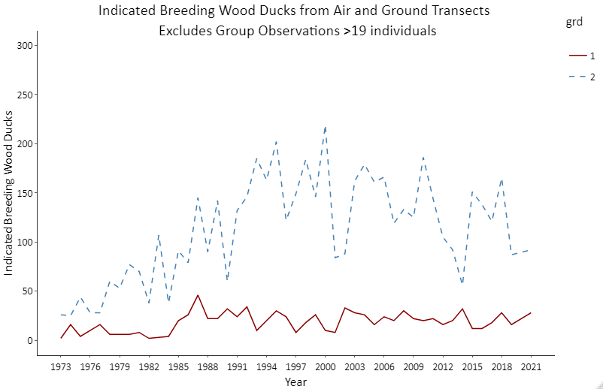

**Figure 15** - Annual relationship between wood duck counts by air observers (red line) and ground observers (blue line) during the Wisconsin Aerial Spring Waterfowl Survey, 1973-2021.

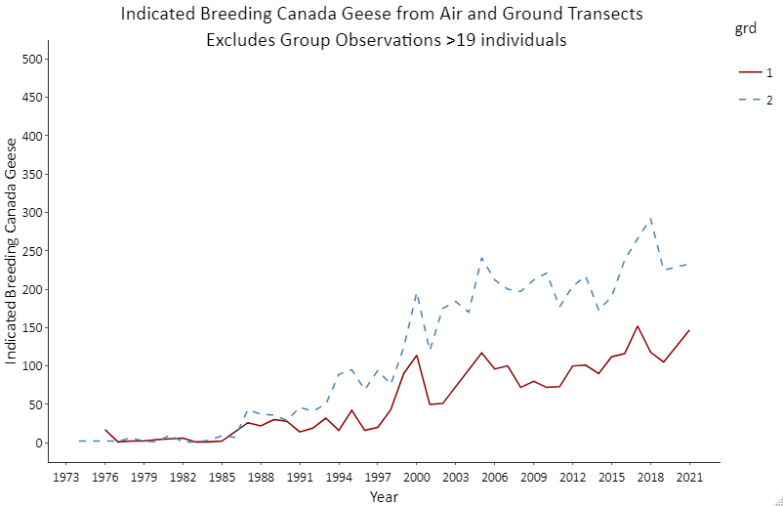

**Figure 16** - Annual relationship between Canada goose counts by air observers (red line) and ground observers (blue line) during the Wisconsin Aerial Spring Waterfowl Survey, 1973-2021.

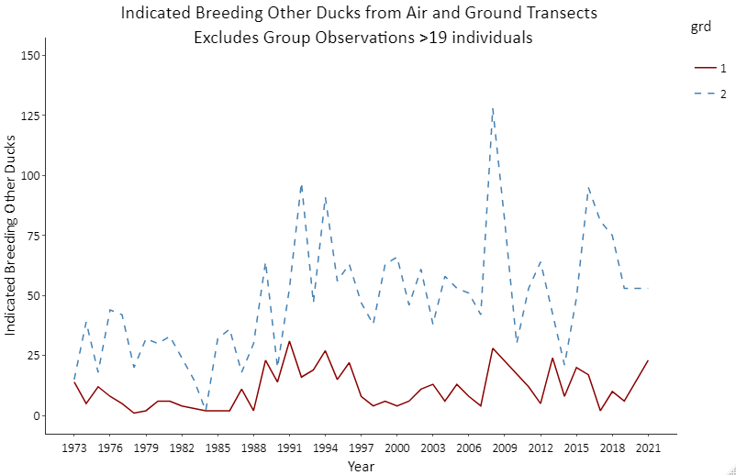

**Figure 17 -** Annual relationship between “other duck” counts by air observers (red line) and ground observers (blue line) during the Wisconsin Aerial Spring Waterfowl Survey, 1973-2021.

1. Kéry, M. and M. Schaub 2012. Bayesian population analysis using WinBugs. A hierarchical perspective. Academic Press.
2. Aerial Visibility Correction Factor = ratio of number of species-specific individuals seen from the ground divided by the number seen from the air on air-ground segments, pooled across strata. To achieve a desirable coefficient of variation (CV) value in the aerial visibility correction factor, previous years of air-ground data were iteratively added until CV was <20%. In 2021, aerial visibility correction factors for mallards, blue-winged teal, wood ducks, Canada geese, and “other ducks” were derived using 2, 13, 6, 2, and 13 years of air ground data, respectively.
3. SEC = Southeast Central, NHI = Northern High, NLO = Northern Low, SWD = Southwest Driftless Strata.
4. Lesser Scaup, Buffleheads, and all non-duck/goose waterbirds are excluded from analysis. Common duck species included as “other ducks” include: Ring-necked duck, Common Goldeneye, Northern Shoveler, Hooded Merganser, Common Merganser, Gadwall, Green-winged teal, and Canvasback.